**Title: Homicides increase variation in lifespans in Mexico and its States, 2005-2015.**

**Authors:** José Manuel Aburto a

**Corresponding author:** José Manuel Aburto. Tel. number: +45 65 50 94 16

Email: [jmaburto@health.sdu.dk](mailto:jmaburto@health.sdu.dk)

**Author affiliations:** a Max Planck Odense Center on Biodemography of Aging; IST - EBB/Epidemiology, Biostatistics and Biodemography; University of Southern Denmark.

Address: J.B. Winsløws Vej 9. DK-5000 Odense C, Denmark

**Classification:** Latin America,Violence, Population Health and Demography

**Keywords:** violence, homicide, lifespan variation, life expectancy, demography.

**Abstract**

Lifespan variation is a dimension of public health that has arisen as an important topic since it addresses the growing interest in health inequalities and its linkage with health behavior. Studying both life expectancy and lifespan variation is important since individuals make decisions based not only on their expected lifetime, but also on the uncertainty surrounding it. In Mexico, life expectancy stagnated in the first decade of the twenty-first century because of the unprecedented rise of homicide mortality after 2005 and the burden of diabetes mortality throughout the decade. The effect of violence was such that improvements in life expectancy made by other causes of death, such as birth conditions and respiratory diseases, were wiped out by homicides, particularly in males. In this paper, we assess the impact of violence, through homicides, on life expectancy and on the uncertainty surrounding age at death in Mexico and its 32 state. We use life disparity as a dispersion indicator. Between 1995 and 2005, homicides decreased life disparity, while diabetes mortality explained most of increases in variation. However, between 2005 and 2015 homicides explained most of increases in life disparity, mainly concentrated in young-adult ages. These results underscore the effect of homicides on the unpredictability of time of death that the Mexican population is experiencing. They reinforce the need for new policies targeting reductions in homicide mortality, since clearly those implemented over the last ten years have not been successful in reducing the burden of violence in the country.

**Extended Abstract**

**Introduction**

Lifespan variation is a dimension of public health that has arisen as an important topic since it addresses the growing interest in health inequalities and its linkage with health behavior (1). Studying both life expectancy and lifespan variation is important since individuals make decisions based not only on their expected lifetime, but also on the uncertainty surrounding it (2).

In Mexico, life expectancy stagnated in the first decade of the twenty-first century because of the unprecedented rise of homicide mortality after 2005 and the burden of diabetes mortality throughout the decade (3). Homicide rates more than doubled between 2007 and 201.2 In 2011 (4), the number of homicides reached a peak, with over 20 homicides for every 100,000 people, with a parallel rise in extortion and kidnapping rates (5).

The effect of violence was such that improvements in life expectancy made by other causes of death, such as birth conditions and respiratory diseases, were wiped out by homicides, particularly in males (6). As a result every state in Mexico experienced losses in life expectancy between 2005 and 2010 and some states, like Chihuahua in the northern part of the country, the loss was almost of 3 years in males (6). Although these results underscore important consequences of the rise in homicide mortality, they mask variation in lifespans, a fundamental inequality between individuals (7).

In this paper, we assess the impact of violence, through homicides, on life expectancy and on the uncertainty surrounding age at death in Mexico and its 32 states. We cover a 20 year period from 1995 to 2015 and analyze females and males separately. We chose this particular period because it covers two comparable 10-year periods: 1995-2005, period during which homicides rates fell down, and 2005-2015 when an unexpected increase in homicide rates began, paralleling the so-called War on drugs.

**Study data and Methods**

Data on deaths from vital statistics files publicly available through the Mexican National Institute of Statistics and Geography were used (8). These data include information on cause of death by age at the time of death, sex, and place of occurrence from 1995 to 2015. Additionally, we used population estimates corrected for completeness, age misstatement, and international migration available from the Mexican Population Council to construct age-specific death rates by sex and state (9).

***Cause-of-death classification***

We classify deaths in ten categories according to previous studies targeting the main causes of death in Mexico (6). The first category refers to conditions amenable to medical service. We analyze separately diabetes, ischemic heart diseases (IHD), HIV/AIDS, lung cancer, cirrhosis, road traffic accidents, suicide, homicides, and the rest of causes of death labeled “Other causes”.

Originally, data on deaths were classified according to the International Classification of Diseases (ICD), revision 9 for years 1995-1997 and revision 10 for 1998-2015. Previous studies have checked the validity of the cause-of-death codes used in this paper and did not find cause-specific ruptures in the transition from ICD 9 to ICD 10 (10).

***Dispersion measure***

Several dispersion measures have been proposed to analyze lifespan variability (11). In this study, $e^{†}$ is used as a dispersion indicator and we refer to it as “life disparity”. It is defined as the average remaining life expectancy when death occurs, or life years lost due to death (12, 13). For example, if a cohort of newborns die at the same age then the value of $e^{†}$ is zero; while when death is very variable, people will die before their expected lifetime, contributing lost years to life disparity. In lifetable notation it is defined as:

$e^{†}= -\int_{0}^{ω}{l\left(x\right)\text{μ(}x)e\text{(}x)\text{d}x}=-\int_{0}^{ω}{l\left(x\right)\text{ ln}l\left(x\right)\text{d}x}$.

where $l\left(x\right)\text{, } \text{μ(}x), e\text{(}x)$ and $ω$ are the survival function, the force of mortality, life expectancy at age $x$, and the open-aged interval (100+ in our case), respectively. This indicator was chosen because it has an easy to understand interpretation and it is decomposable (14, 15). These properties allow quantifying the impact of age and cause-specific mortality on changes in life disparity over time. The high correlation with other variation indices, such as Keyfitz entropy, coefficient of variation, or the Gini coefficient, suggests that the main results would not differ by a large extent regardless of the measure used (11).

***Demographic and statistical methods***

To mitigate random variations, these rates are adjusted in two steps. First, cause-specific death rates over age and time for each state and sex separately using a 2-d p-spline were smoothed (16). Second, smoothed cause-specific deaths were rescaled to raw all-cause death rates for each sex and state. Period life tables for males and females from 1995 to 2015 were calculated following standard demographic methods (17). Life expectancies and life disparities were calculated and cause-specific contributions to the difference between 1995-2005 and 2005-2015 were estimated using standard decomposition techniques (18).

**Preliminary Results**

Life expectancy increased gradually between 1995 and 2005 in both females and males from 75.3 and 69.2 years to 76.7 and 71.3, respectively. However, from 2005 to 2010 life expectancy decreased for males (from 71.3 to 71.0) and stagnated for females. By 2015, males showed a slow recovery causing life expectancy to return to its 2005 level, while females improved life expectancy by an additional year. Life disparity showed inverse patterns compared to life expectancy. From 2005 to 2015, uncertainty surrounding age at death increased for males and remained constant for females. Figure 1 shows age-cause specific contributions to changes in male life expectancy (top panel) and life disparity between ages 5 and 80. Between 1995 and 2005, homicides decreased life disparity, while diabetes mortality explained most of increases in variation. However, between 2005 and 2015 homicides explained most of increases in life disparity, mainly concentrated in young-adult ages.

These results underscore the effect of homicides on the unpredictability of time of death that the Mexican population is experiencing. They reinforce the need for new policies targeting reductions in homicide mortality, since clearly those implemented over the last ten years have not been successful in reducing the burden of violence in the country.

Figure 1 Age-cause specific contributions to changes in male life expectancy $(e_{0})$ and life disparity $\left(e^{†}\right)$ between 1995-2005 and 2005-2015 for ages above 5 and below 80.

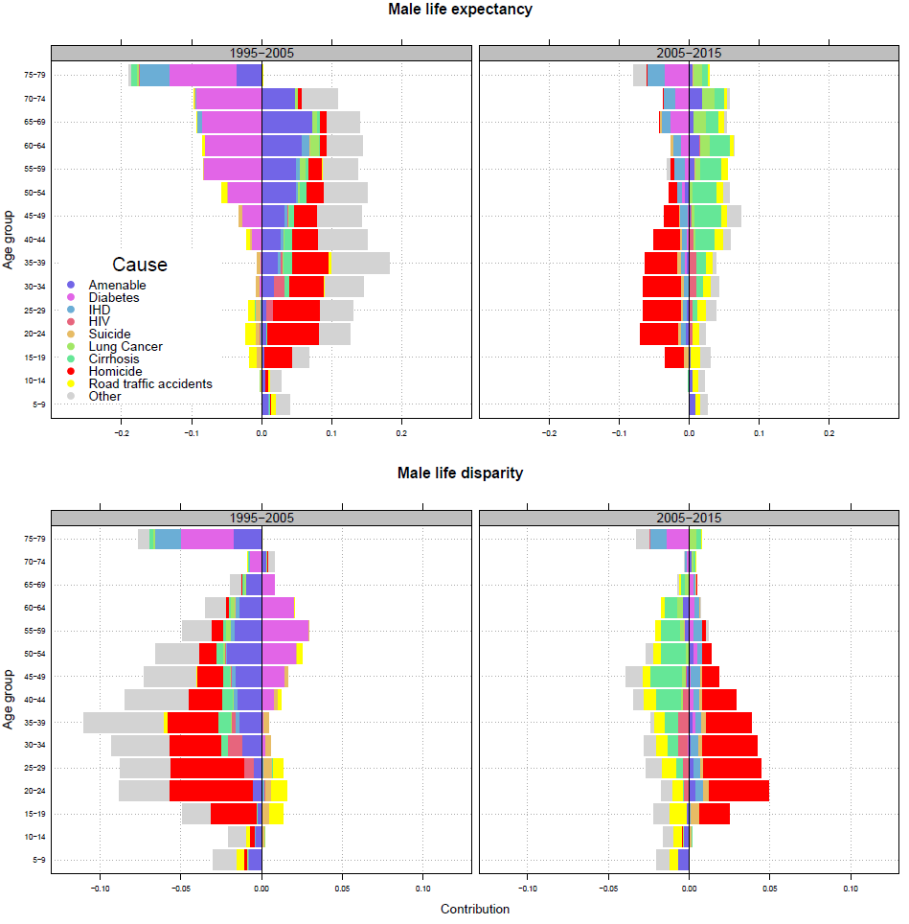

**References**

1. Marmot M. Inequalities in health. New England Journal of Medicine. 2001;345(2):134-5.

2. van Raalte AA, Kunst AE, Deboosere P, Leinsalu M, Lundberg O, Martikainen P, et al. More variation in lifespan in lower educated groups: evidence from 10 European countries. International Journal of Epidemiology. 2011:dyr146.

3. Canudas-Romo V, García-Guerrero VM, Echarri-Cánovas CJ. The stagnation of the Mexican male life expectancy in the first decade of the 21st century: the impact of homicides and diabetes mellitus. J Epidemiol Community Health. 2015;69(1):28-34.

4. Gamlin J. Violence and homicide in Mexico: a global health issue. The Lancet. 2015;385(9968):605-6.

5. Canudas-Romo V, Aburto JM, García-Guerrero VM, Beltrán-Sánchez H. Mexico's epidemic of violence and its public health significance on average length of life. Journal of epidemiology and community health. 2017;71(2):188-93.

6. Aburto JM, Beltrán-Sánchez H, García-Guerrero VM, Canudas-Romo V. Homicides in Mexico reversed life expectancy gains for men and slowed them for women, 2000–10. Health Affairs. 2016;35(1):88-95.

7. Colchero F, Rau R, Jones OR, Barthold JA, Conde DA, Lenart A, et al. The emergence of longevous populations. Proceedings of the National Academy of Sciences. 2016.

8. INEGI. National Institute of Statistics: Micro-data files on mortality data 1995-2015 2017 [Available from: <http://www.beta.inegi.org.mx/proyectos/registros/vitales/mortalidad/default.html>.

9. CONAPO. Mexican Population Council: Population estimates. 2017 [Available from: <https://datos.gob.mx/busca/dataset/activity/proyecciones-de-la-poblacion-de-mexico>.

10. Aburto JM, Riffe T, Canudas-Romo V. Stagnation, deterioration abd disparities on adulthood survival in Mexican states, 1990-2015. 2017.

11. van Raalte AA, Caswell H. Perturbation analysis of indices of lifespan variability. Demography. 2013;50(5):1615-40.

12. Vaupel JW, Canudas-Romo V. Decomposing change in life expectancy: A bouquet of formulas in honor of Nathan Keyfitz’s 90th birthday. Demography. 2003;40(2):201-16.

13. Vaupel JW, Zhang Z, van Raalte AA. Life expectancy and disparity: an international comparison of life table data. BMJ open. 2011;1(1):e000128.

14. Shkolnikov VM, Andreev EM, Zhang Z, Oeppen J, Vaupel JW. Losses of expected lifetime in the United States and other developed countries: methods and empirical analyses. Demography. 2011;48(1):211-39.

15. Zhang Z, Vaupel JW. The age separating early deaths from late deaths. Demographic Research. 2009;20(29):721-30.

16. Camarda CG. MortalitySmooth: An \textttR Package for Smoothing Poisson Counts with $P$-Splines. Journal of Statistical Software. 2012;50:1-24.

17. Preston SH, Heuveline P, Guillot M. Demography. Measuring and Modeling Population Processes: Blackwell; 2001.

18. Horiuchi S, Wilmoth JR, Pletcher SD. A decomposition method based on a model of continuous change. Demography. 2008;45(4):785-801.